Calculus 3 Lecture 15.2: How to Find Divergence and Curl of Vector Fields

Divegence and curl are two characteristics of how “flow” is “behaving” on a Vector field in a small neighbourhood around a given point “”.

Divergence: A measurement of how much Fluid/flow enters the neighbourhood around “” compared to how much leaves.

- If more fluid/flow enters the neighbourhood than leaves it, then divergence will be negative(-) at “”. Think of this as flow/fluid gathering at the point.

- If the same amount of fluid/flow enters as leaves, then divergence will be zero at “”, incompressible.

- If more fluid/flow leave the neighbourhood than enters it, then divergence will be positive(+) at “”. Think of this as flow/fluid draining (diverging) at the point. Divergent.

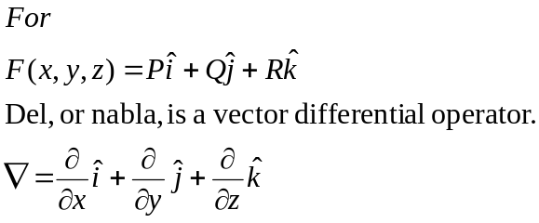

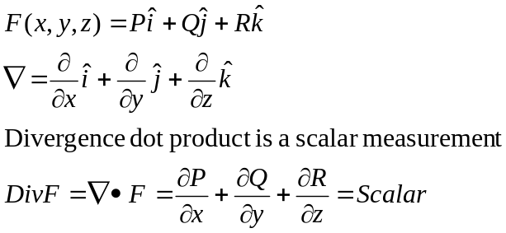

Curl: The measurement of rotation of the vector field in the neighbourhood around “P”.
How much the paddle would spin

If curl is positive (+) at a point then the flow/fluid would spin counterclockwise.

If curl is negative (-) at a point then the flow/fluid would spin clockwise.

If curl = 0 at a point then no rotation. Irrotational.

Cross Product
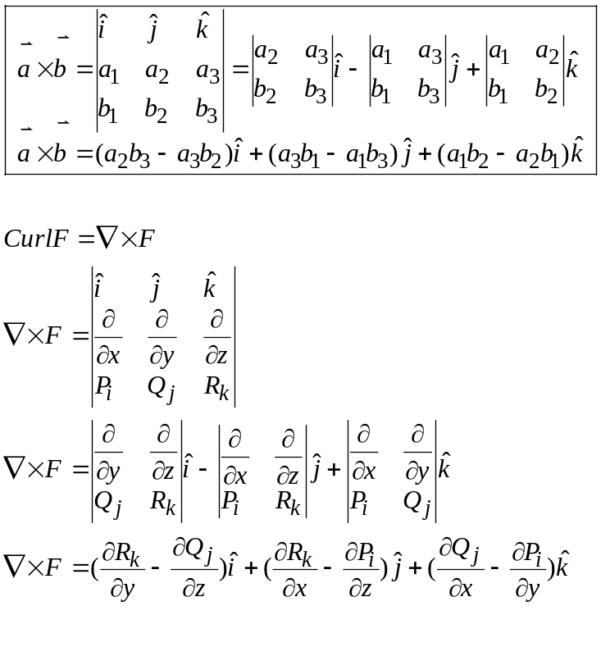

Example
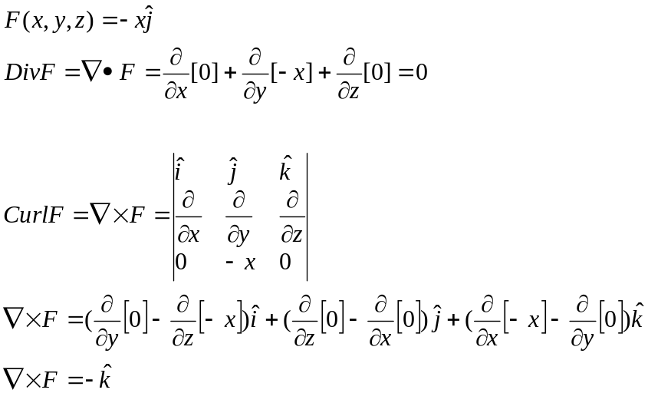

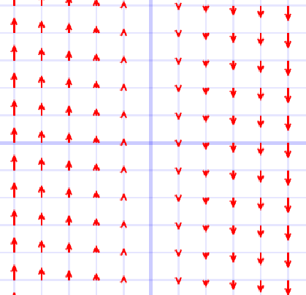
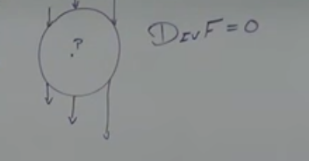

Example
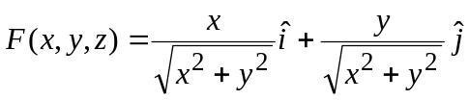

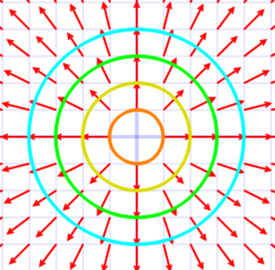
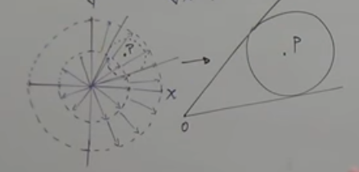
More Arc length more vector leaving (diverging)

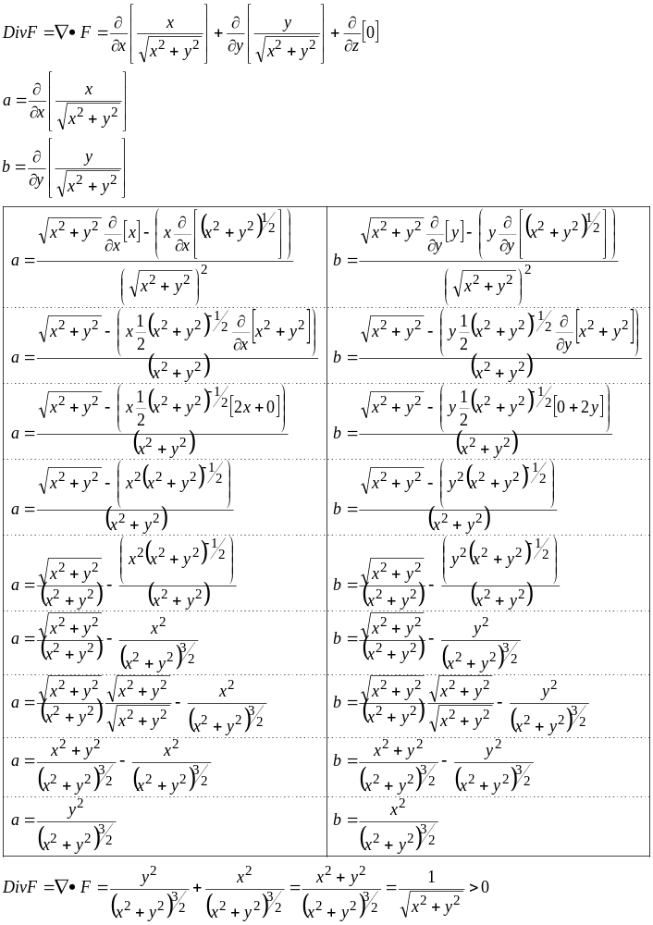
Vector field is diverging more leaving than entering.

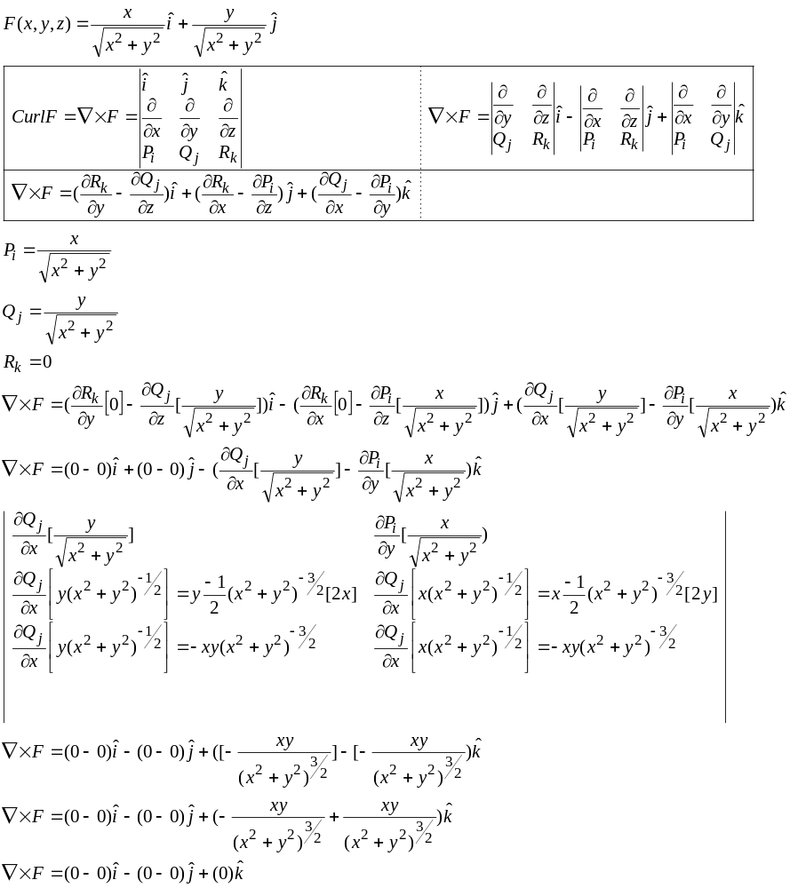
No spin irrotational

Example
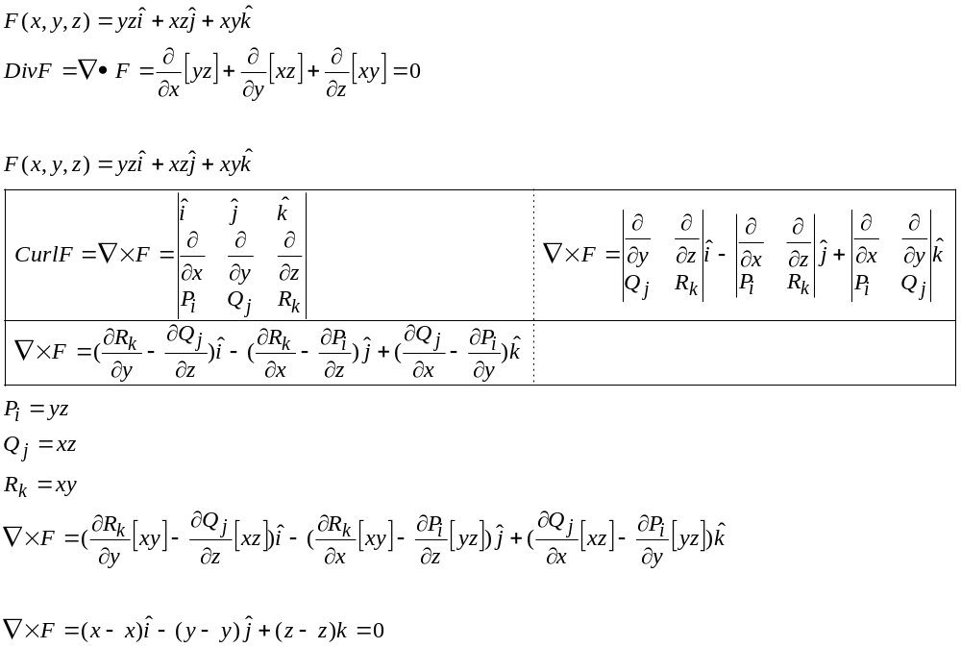

Example
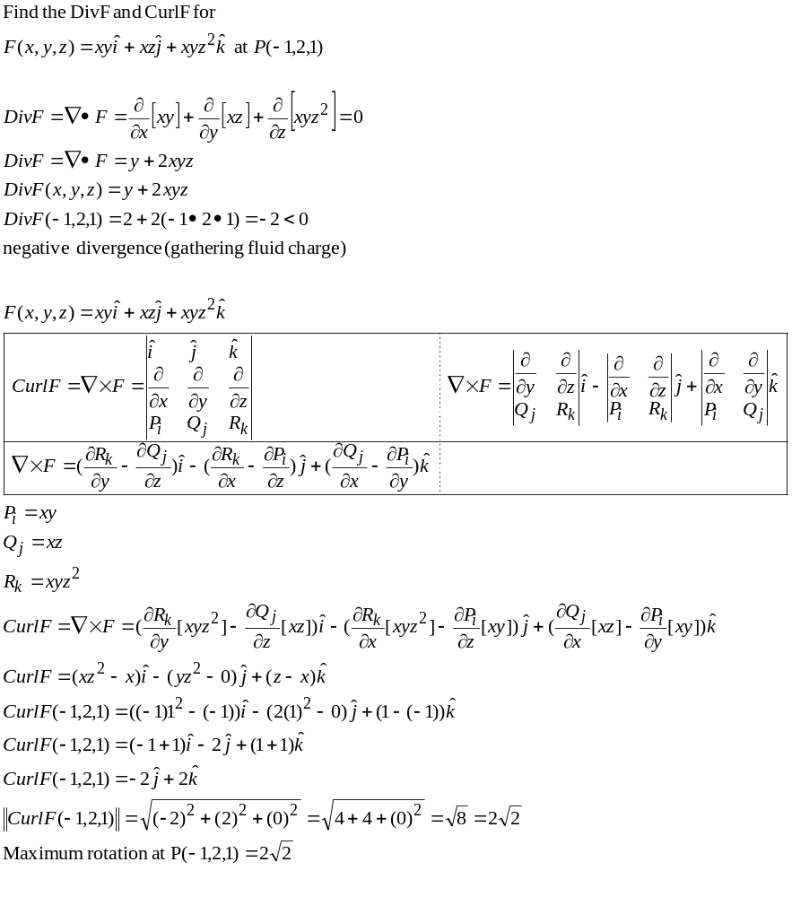

Maximum rotation of the curl vector is the magnitude of the curl vector 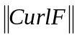
Only happens if paddle is parallel to curl vector.

